Things we still need to do for app:

1. What data are currently included in the app relative to identified validation errors
   1. Throw out individual records but kept “good data” in?
   2. Threw out all of lake/yr combo for some things and ignored other?
   3. What do we want to do when this “goes live”?
      1. I would be most comfortable throwing out entire sites if there was a questionable record at that site.
   4. *Currently, the csv database in the app is one that I ran several validations through and “fixed” several pieces that were wrong…(e.g., 0’s that should be nulls, wrong lake codes or species codes, etc.).*
      1. *However, I did not remove records that would have “separated” a sample (i.e., I only removed records when errors applied to the whole sample). Therefore, no validation rules have been applied for anything at the individual fish level (e.g., impossible lengths or weights).*
2. Do we have code for Kurt to use to test new data for validation?
   1. How do we then upload (just append to csv?)
   2. *I will be working on this and get it done before the end of June. Yes, plan is to just append to the old csv, then you would have to reload the app onto the server with the updated csv database.*
3. Do we have a way to present percentile data once a summary data file is created for historic samples?
   1. *I have a new plan of action for this…*
      1. *Picture this…you’re looking at the output from a LMB sample at Dripping Springs…you see, oh, the LMB from this sample is at the 40th percentile for PSD. My first question after that is…how high does PSD have to be to reach the 90th percentile?? No one knows…unless you go around cherry picking through other samples in the app until you find one that’s around the 90th percentile.*
         1. *My point is…it’s like giving the user a piece of the puzzle, but not the whole answer. The user doesn’t know the potential range or distribution of the metric in question, so just knowing we’re at the 40th percentile doesn’t mean a ton for a management standpoint.*
      2. *So, what I have in mind is something a little more interactive. Once a “percentile database” is built, I can code something similar to the picture I’ve included below. The user will be able to select the species, year range, and metric they want to dive into…then the output will give a histogram of the distribution of that metric statewide, as well as a numerical chart of the exact percentiles in 10’s. Both will be downloadable to save somewhere if the user doesn’t want to go through this simple selection process every time. This tab will run off the percentile database, so every time that gets updated, the tab will reflect it.*
   2. *I will also code a “stocking information” tab from the hatchery database that will be similar to the percentile tab…that’s what I’m thinking right now anyway. Just have the user be able to select a lake, year range, and species (optional) and a chart will pop up to the side about which species, how many, how big, what year, etc.*

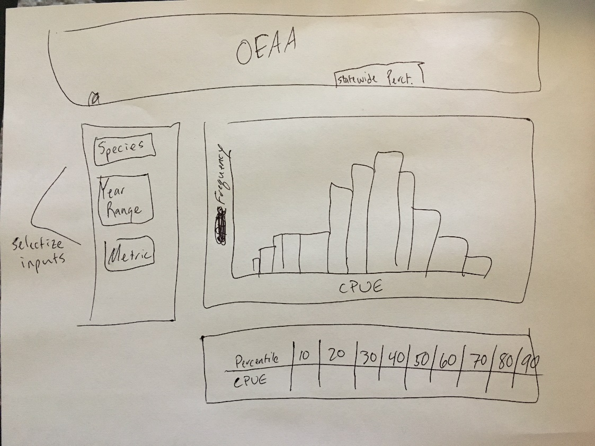

Changes I’d like to see:

1. Can we provide code and text version for dropdowns on single species analysis selection boxes (second tab) like we have done on the first tab?
   1. *Accomplished, along with a slight change to the format of that tab.*
2. Can we produce overall Wr (i.e., mean value in addition to PSD size class versions)
   1. *Good idea – Accomplished - added “Overall” size category to the bottom of Wr table.*
3. Can we export an age-length key in table format?
   1. *Accomplished – download buttons for exporting both observed ALK and smooth ALK now underneath ALK plot – exports to nice csv format.*
4. Grid on the age-length key bubble plot uses weird spacing on X-axis…could we have this do some more logical gridding (e.g., lines ever 10mm or 10 lines between major axis marks or whatever makes sense given how this gets specified)? Old spacing may be related to English units (0 has a line and the next x-tick to fall on a line is 300…roughly 1 foot).
   1. *The x-axis spacing is not illogical, I actually did it somewhat on purpose. The spacing is representative of the length grouping (10, 15, or 20 mm) used to construct the age-length key. As of now, this is the only way the user can tell which length increment the age-length key is using.*
5. Age-frequency histogram, y-axis should be proportion rather than frequency to match length-frequency? (also more applicable for comparisons when total sample sizes differ…which is probably the case more often than not).
   1. *Accomplished – both are now proportion-based.*
6. Is it possible to display annualized mortality (A) to one decimal place and instantaneous (Z) to two decimal places? If not, this is not a huge deal…just seems overkill to display 2 decimal places on A, but I realize it might be harder to format different rows of the same table differently.
   1. *Yeah this is really hard to do…in general, each field (column) has a designated 1) data type and 2) decimal count. You have to remember these tables are still actual generated tables (table by definition) and not just displays of numbers.*
7. Add R2 on catch curve plot?
   1. *Accomplished – R2 now appears on top of plot*
8. Add mean weight by age to mean TL by age table or produce totally new table (probably new table is best). Would be similar to code for mean length, but using wt column rather than TL column on key expansion.
   1. *Accomplished – Made new table underneath*
9. Should we combine length at age plot and von bert plot (no need for a “connect the dots” line connecting the mean values used in the first graph)? Maybe the von bert curve with the data points and then a different symbol for mean value?
   1. *Accomplished – yeah I like this better.*

Lower priority and more involved (perhaps for v 2.0):

1. Estimate natural mort using various methods from length/age/total mortality info?
2. Add theoretical maximum age?
3. Reference R2 value to weighted linear regression
4. Add conversion from grams to pounds option
5. Change total effort table for electrofishing – reference gear length not effort
   1. CPUE unit reminders (per hour, per net night, etc.)